

**Participants**

**will receive Professional Growth Hours and $400**

**upon completion**

**of the series!**

|  |
| --- |
| Community of  Center and Family Child Care Early Childhood Teachers and Directors (Alameda County only) are invited to learn an overview of the California Childhood Educator Competencies. The Competencies describe the knowledge, skills, and dispositions that Early Childhood Educators need  in order to provide high quality care  and education to young children  and their families. |
|  |

**Moving the Needle: Boosting Children’s Outcomes Through Teacher Competencies**

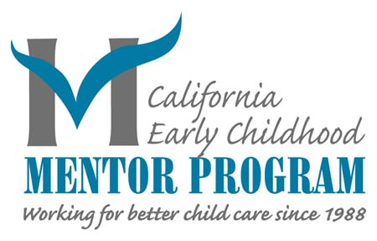

**Chabot College | 25555 Hesperian Blvd, Hayward 94545**

* **March 4th, 9AM – 12PM**
* **March 11th, 9AM – 12PM**
* **April 1st, 9AM – 1PM**
* **May 20th, 9AM – 1PM**
* **June 3rd, 9AM – 1PM**
* **December 10th, 9AM – 1PM**
* **January 21st, 9AM – 12PM**
* **January 28th, 9AM – 12PM**
* **February 4th, 9AM – 12PM**
* **February 11th, 9AM – 12PM**

**Community of Practice DATES**